Intro

* Magnitude: an amount
* Vector: magnitude + direction
  + Can be represented by an arrow pointing in the direction with a length proportional to the magnitude
  + in symbols representing vector quantities, there’s an arrow above it
$→$

$v$

* Scalar: magnitude
* Scalars scale vectors
* When working with units with no numbers, units go in [ ]

[Calculus](https://docs.google.com/document/u/1/d/12D5x2rrUFME6wrr7jL8w8T-2261QIYmZX8NobPeU7Pc/edit#heading=h.k4wndyb7b8u3):

* Limits
* Taking first and second derivatives
* Taking indefinite and definite integrals
* sum/difference, product, quotient, chain rules
* First Fundamental Theorem of Calculus
* U-substitution
* Differential equations

Linear Algebra

* Addition and subtraction
  + Graphically
    - Connect the head of one vector to the tail of the next, without altering the orientation
    - Resultant is from the tail of the first vector to the head of the last
    - To subtract a vector, change the direction it points to the opposite
  + Analytically
    - Use cosine to get the horizontal components
    - Use sine to get the vertical component
    - Sum the horizontal components
    - Sum the vertical component
    - Use Pythagorean theorem to find the magnitude of the resultant
    - Use arctangent to find the angle of the resultant
* Unit vector notation
  + $\hat{i}$ (read: i hat) represents 1 unit in the x-direction
  + $\hat{j}$ represents 1 unit in the y-direction
  + $\hat{k}$ represents 1 unit in the z-direction
  + A vector can be represented as $a_{x}\hat{i}+a_{y}\hat{j}+a_{z}\hat{k}$
    - ax units along the x-direction, ay units along the y-direction, az units along the z-direction
  + ax, ay, az are the scalar components
  + $\hat{i}, \hat{j}, \hat{k}$ are vector components
* Norming
$\sqrt{x^{2}+y^{2}+z^{2}}$

$||a×b||=absinθ$

* Scaling
  + A scalar multiplied by a vector
  + The scalar scales (multiplies) the magnitude component of the vector
* Cross products
  + Multiplying a vector by a vector
 $\underline{A}×\underline{B}$

 + The x reads as “cross”
  + The result is called a pseudovector
  + To solve
    - First: “FOIL”
      * Ex: $(4\hat{i}+3\hat{j})×(-3\hat{i}-4\hat{j})$
 $(4\hat{i}×-3\hat{i})+(4\hat{i}×-4\hat{j})+(3\hat{j}×-3\hat{i})+(3\hat{j}×-4\hat{j})$

   - Then, solve each part
      * The magnitude portion is $||\underline{A}||||\underline{B}||sinθ$, where theta is the smaller angle between $\underline{A}$ and $\underline{B}$. (Note: in this method, the axis have perpendicular relationships, and sin(90o)=1)
      * For the direction portion, use the right hand rule
      * Using your right hand, point your 4 fingers in the direction of $\underline{A}$ (note whether $\hat{i}, \hat{j}, \hat{k}$, and +/- sign). Then, orient your hand so that the 4 fingers are still pointing in the same direction, but able to curl in order to point in the direction of $\underline{B}$. Stick out your thumb, and that is the direction of the pseudovector
      * 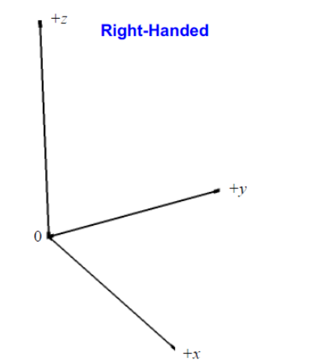
      * 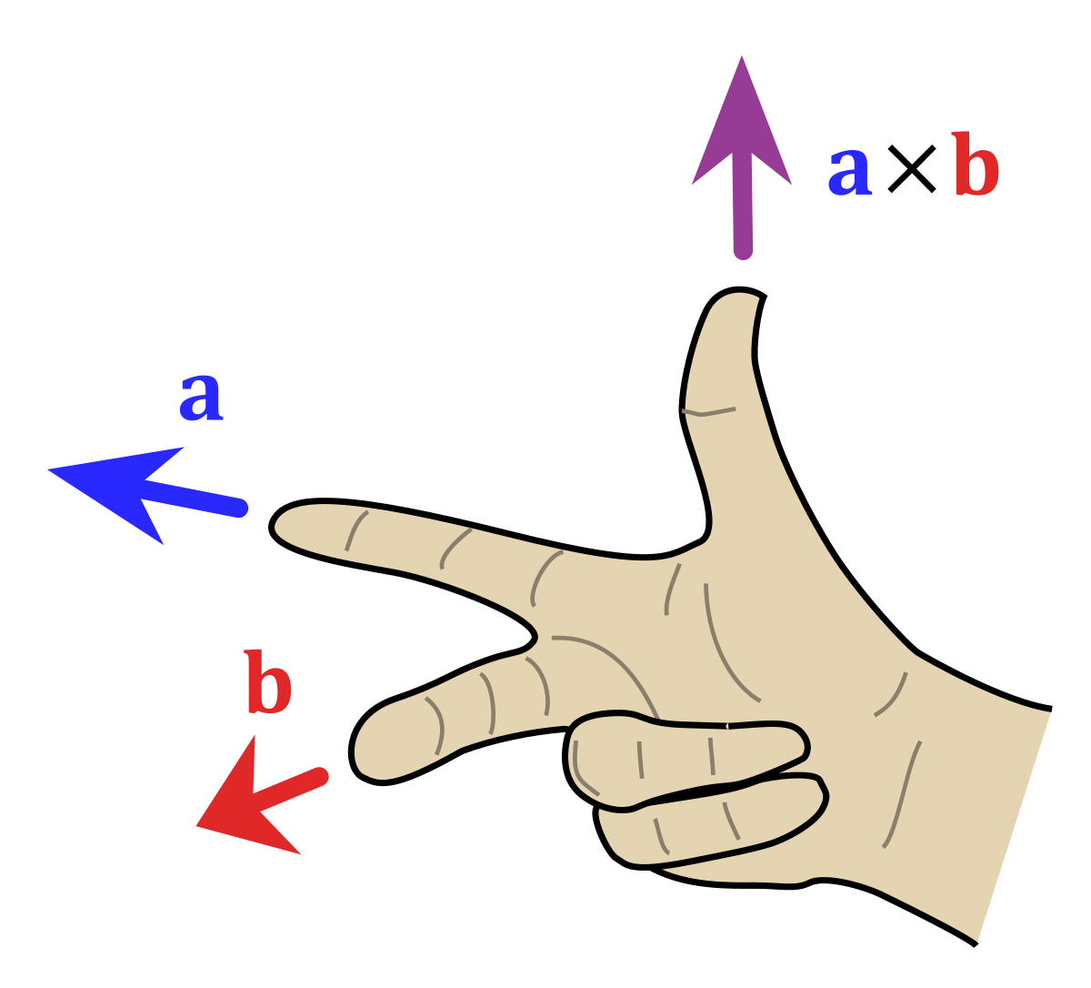
      * Ex: $(4\hat{i}×-3\hat{i})+(4\hat{i}×-4\hat{j})+(3\hat{j}×-3\hat{i})+(3\hat{j}×-4\hat{j})$
 $(4\hat{i}×-3\hat{i})$

       + Same direction so solves to 0
 $(4\hat{i}×-4\hat{j})$

       + Magnitude: 4*4=16
        + Direction: fingers point in positive $\hat{i}$, curlable to negative $\hat{j}$, so thumb points in negative $\hat{k}$
 $-16\hat{k}$

 $(3\hat{j}×-3\hat{i})$

      + Magnitude: 3*3=9
        + Direction: fingers point in positive $\hat{j}$, curlable to negative $\hat{i}$, so thumb points in positive $\hat{k}$
 $9\hat{k}$

 $(3\hat{j}×-4\hat{j})$

      + Same directions so solves to zero
      * Solution: $-16\hat{k}+9\hat{k}=-7\hat{k}$
  + Properties
    - Crossing two vectors of the same direction results in 0
$\underline{A}×\underline{B}=-(\underline{B}×\underline{A})$

* Dot products
  + Multiplying a vector by a vector to get a scalar
 $\underline{A}∙\underline{B}=||A||||B||cosθ$

 + Intuitively, it’s multiplying the magnitudes of projections along an axis
    - 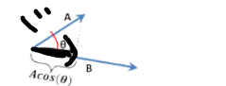

Kinematics

* Motion diagram
  + Represents motion by using dots to show the position of an object at interval snapshots of time
  + At each dot, draw an arrow that represents the velocity at that instant
  + Above but between 2 velocity vector arrow, draw another arrow to show how the velocity changed between those 2 instances (this represents acceleration)
* Position ($\underline{x}$) (pretend the top bar is vector arrow): a location in 3D space
* Displacement ( $Δ\underline{x}$ or $\underline{d}$)
  + a change in position
 $Δx=\underline{x_{f}}-\underline{x_{i}}$

 + Scalar (d) is the path length (distance)
  + The first integral of velocity vs time
  + The second integral of acceleration vs time
* Velocity ($\underline{v}$)
  + Average velocity ${\underline{v_{}}}_{avg}=\frac{Δ\underline{x}}{Δt}$
  + Scalar average speed $s_{avg}=\frac{path length}{Δt}$
  + Instantaneous velocity (${\underline{v}}_{inst}$)
    - velocity at a single point in time
  + The first derivative of position vs time
  + The first integral of acceleration vs time
* Acceleration ($\underline{a}$)
  + Average acceleration: ${\underline{a}}_{avg}=\frac{Δ\underline{v}}{Δt}$
  + Instantaneous acceleration: ${\underline{a}}_{inst}$
    - Acceleration at a single point in time
  + The first derivative of velocity vs time
  + The second derivative of position vs time
* Kinematic relationship
  + Requires acceleration to be constant
$\underline{v}={\underline{v}}_{0}+\underline{a}t$

$\underline{x}={\underline{x}}_{0}+{\underline{v}}_{0}t+0.5\underline{a}t^{2}$

${\underline{v}}^{2}={{\underline{v}}_{0}}^{2}+2\underline{a}Δ\underline{x}$

* Projectile motion
  + A projectile is launched into the air with an initial velocity (no speed boosts)
  + Projectile experience freefall: no external forces other than gravitational
  + Trajectory: path
  + Range: the horizontal distance covered by the projectile
  + Along the vertical axis, constant acceleration of g, and velocity affected by only that
  + Along the horizontal axis, 0 acceleration, and constant velocity

Newton’s Laws of Motion

* Law of inertia: an object’s motion remains unchanged unless acted upon by a net force
$\sum{}\underline{F}=m\underline{a}$

* For each force, there exists a force equal in magnitude and opposite in direction
* Acceleration by gravity (g) is about 9.81 or 10 m/s2
* Static equilibrium: net force = 0N
* Forces
  + Weight = gravitational force = mg
  + Normal force: the force exerted by a surface perpendicularly/normally
  + Contact: a push through a surface
  + Tension: a pull through a string
  + The component of weight parallel to an inclined plane is $mgsinθ$
  + The component of weight normal to an inclined plane is $mgcosθ$
  + Static friction
    - The friction that keeps an object from sliding
    - Equals whatever force it needs to be to oppose the translational motion, as long as that amount of force is less than the max static friction
    - Max static friction: $F_{N}μ_{s}$
    - The normal force is based on the surface the slipping motion would be on
    - The coefficient of friction is based on the material of the object and surface. Usually less than 1. The static coefficient of friction is usually greater than the kinetic coefficient of friction
  + Kinetic friction
    - Friction opposing the translational motion of an object along a surface
 $F_{N}μ_{k}$

 + Drag force
    - A resistive force experienced by an object traveling in a fluid
    - An object traveling in Earth’s atmosphere might experience quadratic drag force: $-b{\underline{v}}^{2}$
    - A small object falling through something viscous may experience linear drag force: $-k\underline{v}$
    - b and k are drag constants
      * Units of b are $\left[\frac{kg}{m^{}}\right]$
 $b=0.5ρ_{fluid}c_{d}A$

       + cd is drag coefficient
        + A is crosssection area
        + $ρ_{fluid}$ is the density of the fluid the object is traveling through
      * Units of k are $\left[\frac{kg}{s}\right]$
      * Influenced by the object’s shape
    - Since the drag force at a specific instance is in terms of instantaneous velocity, differential equations derived from Newton’s second law setup would be needed in order to get the v(t) equation
      * Generic v(t) from quadratic drag force of an object moving at equilibrium with no friction: $v(t)=\frac{mv_{0}}{m+btv_{0}}$
      * Generic v(t) from linear drag force of an object moving at equilibrium with no friction: $v(t)=v_{0}e^{\frac{-bt}{m}}$
    - There exists terminal velocity when drag force is involved. Set up Newton’s second law equation, then find what the instantaneous velocity approaches when acceleration approaches zero
* Free body diagrams
  + A dot represents the system
  + Arrows representing force with length proportional to the force’s magnitude, pointing away from the dot in the direction of the force
  + Forces labeled Fobject experiencing, object exerting
* Systems
  + A system accelerates together, so it would be helpful to first find the acceleration of the system, which can be used as the acceleration of the objects in the system
  + Draw free-body diagrams for the objects in the system
  + Boxes on an elevator: the elevator’s acceleration is the acceleration of the system
  + Atwood machine (massless pulley)
    - 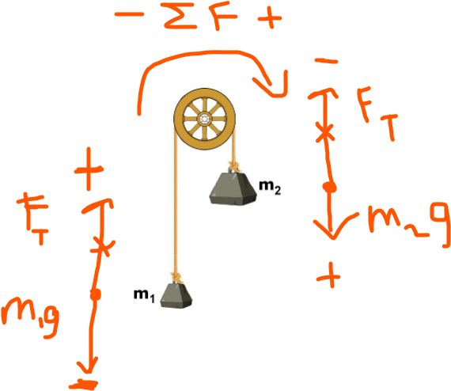
    - The string is massless and has a uniform tension
    - No friction between the pulley and string
    - Pick a direction to be positive for the net force, and draw free-body diagrams based on that orientation
  + Modified Atwood machines (massless pulley)
    - 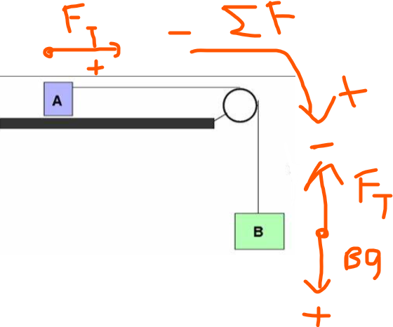
    - An object on a surface with no friction
    - A pulley and string both massless and frictionless
    - The pulley at the end of the surface, supporting a string that connects the object on the surface with an object dangling off the surface
    - The net force acting on this system is the weight of the object dangling off the surface
    - Like the standard Atwood machine, set a direction for positive net force, then draw free-body diagrams based on the orientation
  + The object hanging stationary with 2 strings: use sine and cosine to find the vertical and horizontal components of tensions in each string. Remember that in static equilibrium, the horizontal net force is 0, the vertical net force is 0.
* Modified/Atwood (pulley with mass)
  + 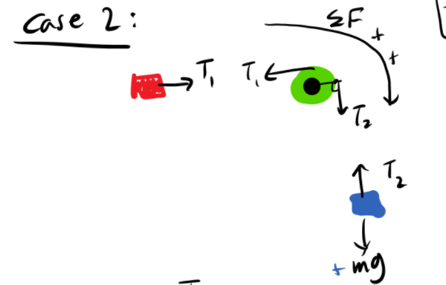
  + The FBD would also include the forces experienced by the pulley
  + Write 2nd law force equations for the two blocks, as well as 2nd law torque equations for the pulley

Masses

* Discrete
  + representing objects as point masses
  + Center of mass
    - The balance point
    - The point of the object that behaves like a point particle
    - The point where all the mass of the object is “concentrated” at
    - The point where gravitational force acts on
    - Closer to where more mass is
    - For shapes with uniform density, the center of mass is at the center of the shape
    - vector
$\frac{sum of (mass * displacement from a set point) for each mass}{sum of all the masses in the system}$

* Continuous
  + representing objects as a continuous piece of mass with an actual shape
  + To calculate the mass of a continuous object, break up the object into an infinite number of infinitely small differential masses
  + Then, use an integral to sum up the mass of each differential mass along the specified length/area/volume
  + $λ$: linear mass density
 $\left[\frac{kg}{m}\right]$

   - Used to calculate the continuous mass of a rod-shaped object
 $λ=\frac{m_{}}{L}=\frac{dm}{dx}⇒dm=λdx⇒m=\int_{0}^{m}{}dm=\int_{x=0}^{x=L}{}λdx$

 $σ$ + : surface density
 $\left[\frac{kg}{m^{2}}\right]$

 $ρ$ + : volume density
 $\left[\frac{kg}{m^{3}}\right]$

 + Center of mass: $\frac{\int{}xdm}{\int{}dm}$

Linear Momentum

* ${\underline{p}}_{system}=m_{total}{\underline{v}}_{COM}$ = sum of mass*velocity for each mass in the system
$\sum{}F=\frac{d\underline{p}}{dt}$

$\sum{}Ft=Δ\underline{p}=J=\int{}Fdt$

* Conservation of linear momentum
  + if net force = 0 and mass is constant, momentum remains constant
  + Collision with linear momentum conservation
    - momentum before = momentum after
    - the COM’s motion remains unchanged
    - If collision is 2D, make sure that momentum is conserved along the axis (vertical and horizontal)

Circular Motion and Rotation

* Angular quantities
  + Basically just like their translational counterparts but in terms of radians, not meters
    - Radian: the angle formed by wrapping the radius along the circumference
    - 2pi radians is one revolution
    - Kinematic relations apply the same way
  + $θ$: angular position
 $S=rθ$

 $ω$ + : angular velocity
    - Second right hand rule: wrap hand around the axis of rotation, oriented in the way that the 4 fingers can curl in the direction of rotation. Stick the thumb out. The thumb points in the direction of angular velocity
 $v_{t}=rω$

 $α$ + : angular acceleration
    - In the direction of torque
$a_{t}=rα$

$a_{c}=rω^{2}$

* Centripetal motion
  + An object having translational motion along a circular path
  + R is the distance the object is from the center of the circle
  + m is the mass of the object
  + $θ$ is the displacement the object has traveled in terms of radians
  + The linear position of the object as a function of time
    - Vector: $Rcosθ\hat{i}+Rsinθ\hat{j}$
    - Magnitude: R
  + The linear velocity of the object as a function of time
    - Vector: $-Rsinθω\hat{i}+Rcosθω\hat{j}$
    - Magnitude: $Rω$
    - This is tangential velocity, the velocity tangent to the circular path, perpendicular to the radius, and in the direction of instantaneous motion of the object
    - Uniform circular motion: tangential velocity magnitude is constant
  + Linear acceleration as a function of time
    - Vector: $-R(cosθω^{2}+sinθα)\hat{i}+R(-sinθω^{2}+cosθα)\hat{j}$
    - Uniform circular motion
      * $ω$ is constant, so $α$ is 0, so vector for that would be $-R(cosθω^{2})\hat{i}+R(-sinθω^{2})\hat{j}$
      * Magnitude: $Rω^{2}=\frac{v^{2}}{R}$
    - This is the net acceleration experienced by the object
      * In uniform circular motion, all of this is also the centripetal acceleration, making all of this causing centripetal force
      * In non-uniform circular motion, some of this net acceleration goes to centripetal acceleration, and some of it goes to tangential acceleration
 $\sum{}F=\sqrt{{F_{c}}^{2}+{F_{t}}^{2}}$

       + Tip: create a “centripetal axis” and a “tangential axis” (they’re perpendicular)
* Torque
  + Rotational force
 $\underline{τ}=\underline{r}×\underline{F}=Iα$

 + Units: [Nm]
  + r is the distance from the axis of rotation to the site where force F was applied
  + F is the translational force that causes the torque
  + Positive torque causes counterclockwise rotation
  + Negative torque causes clockwise rotation
  + If an object is in translational equilibrium and rotational equilibrium, any axis on that object could be treated as the axis of rotation
  + Static ladder problems: set $ΣF_{x}=0$, $ΣF_{y}=0$ and $Στ=0$
* Moment of inertia
  + I
  + Scalar
  + Units: [kgm2]
  + While mass is resistance to translational acceleration, moment of inertia is resistance of rotational acceleration
  + When unconstrained, a mass will spin around its center of mass because that’s where the moment of inertia is the lowest, meaning the least energy would be needed to spin around that point
  + Varies by the shape of the object and where the axis of rotation is
  + Moment of inertia for a point particle is mr2, where m is the mass of the point particle and r is the distance between the point particle and the axis of rotation
  + Moment of inertia for a disk spinning around its center: 0.5mr2
  + Moment of inertia for a continuous body
 $\int_{a}^{b}{}x^{2}dm$

   - a is the displacement from the axis of rotation to the left-most part of the body
    - b is the displacement from the axis of rotation to the right-most part of the body
    - 
  + Parallel axis theorem
 $I_{||}=I_{COM}+m_{T}h^{2}$

   - I|| is the moment of inertia when the object is rotating around an axis that’s parallel to the axis of rotation through the center of mass
    - h is the distance between the two axis of rotations
    - 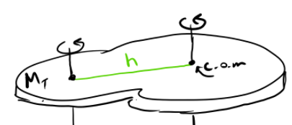
  + Moment of inertia of a ring rotating around its center
 $λ=\frac{dm}{dx}$

   - Chop the ring into an infinite number of point dm’s, with each occupying a dx amount of circumference. That dx amount of circumference is $rdθ$. $dm=λrdθ$
 $I=\int_{θ=0}^{θ=2π}{}r^{2}dm$

   - If $λ$ is constant, I=R2MT
  + Moment of inertia of a disk rotating around its center
 $σ=\frac{dm}{dA}$

   - Chop the disk into an infinite number of ring dm’s, each occupying a dA amount of area. That dA amount of area is $2πrdr$. $dm=σ2πrdr$
 $I=\int_{r=0}^{r=R}{}r^{2}dm$

   - If $σ$ is constant, I=0.5R2MT
  + Moment of inertia of an annular ring around its center
    - Donut shape
    - Just like the setup for the disk, but the limits of integration should go from r=A (the radius of the inner circle) to r=B (the radius of the whole disk)
    - If $σ$ is constant, I=0.5MT(A2+B2)
* Pure rolling
  + Means rolling without slipping
  + Friction must exist
  + After rotating 2pi radians…
  + The center of mass must have been displaced by $2πr$
  + The velocity of the center of mass must have been $rω$
  + The velocity of the point in contact with the surface is 0
  + The velocity of the point furthest from the contact point is $2rω$
  + The object rolled in a straight line if $\sum{}F=0$
  + The acceleration of the center of mass must have been $rα$
* Angular momentum
 $L=Iω$

 + Angular momentum of a system is conserved if $\sum{}τ=0$ and mass remains constant
 $J_{ang}=ΔL=τt=\int{}τdt$

 + Objects traveling in a straight path can have angular momentum relative to a point
 $L=r×p$

   - r is the distance from the point to the object
    - p is the linear momentum of the object
  + Orbital mechanics: r1v1=r2v2
    - 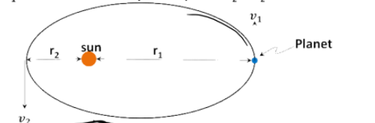

Work, Energy, and Power

* $\sum{}W=ΔK=\sum{}\underline{F}∙\underline{r}=\int_{r_{0}}^{r_{f}}{}\sum{}\underline{F}∙d\underline{r}$, scalar
$K=0.5mv^{2}+0.5Iω^{2}$

* Collisions
  + Momentum is always conserved
  + Elastic collisions: collisions where kinetic energy is conserved
  + Super elastic collision: collisions where kinetic energy is increased
  + inelastic collisions: collisions where the system ends up with less kinetic energy
  + Completely inelastic collision: inelastic collisions where the masses end up sticking together
* Conservative forces: the amount of work done by a force is path-independent
  + Work done by a conservative force c: Wc=-Uc
    - If $\frac{d}{dx}U(x)=0$ and $\frac{d^{2}}{dx^{2}}U(x)>0$, the object is at stable equilibrium
    - If $\frac{d}{dx}U(x)=0$ and $\frac{d^{2}}{dx^{2}}U(x)<0$, the object is at unstable equilibrium
    - If $\frac{d}{dx}U(x)=0$ and $\frac{d^{2}}{dx^{2}}U(x)=0$, the object is at neutral equilibrium
* Gravitational potential energy
  + Ug=mgh only if g is constant
  + If g varies by position, $U_{g}(r)=\frac{-GMm}{r}$
* Conservation of total mechanical energy: $W_{NC}=ΔK+ΔU_{C}$
* Spring force
  + Fs(x)=kx
  + k is the spring constant
  + x is the stretch/compression of the spring
  + F(x) is the force exerted on the spring (or by the spring - 3rd law force pair)
  + Work done on the spring to change its length = the amount of energy stored in the spring = 0.5kx2
  + Spring force is a conservative force
  + If 2 springs are in series
    - The 2 springs stretch different amounts
    - The “equivalent” spring constant keq:
  + If 2 springs are in parallel
    - The 2 springs stretch equal amounts
    - The “equivalent” spring constant is k1 + k2
* A rolling object is both rotating and translating, so it has both rotational kinetic energy and translational kinetic energy
* Power
  + The rate in which energy is transferred
 $P=\frac{dE}{dt}=F∙v$

 + Units of Watt, which is Joules per second

Gravitation

* Gravitational force
 $F_{g}=G\frac{m_{1}m_{2}}{r^{2}}$

 + Vector: $-G\frac{m_{1}m_{2}}{r^{2}}\hat{i}$
  + G=6.67*10-11 Nm2/kg2
  + Only applies to point particles
  + Acceleration due to gravity: $\frac{Gm_{earth}}{{r_{earth}}^{2}}$
  + 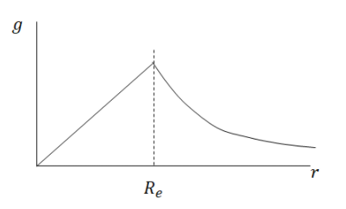
  + As a mass goes below earth’s surface, the acceleration due to gravity it experiences decreases proportionally to r
  + As a mass goes above earth’s surface, the acceleration due to gravity experiences decrease inversely proportional to r2
* Kepler’s Laws
  + Every planet moves in an elliptical orbit, with the sun at one of a focus
  + In an equal time interval, a planet’s orbit sweeps out equal area
    - 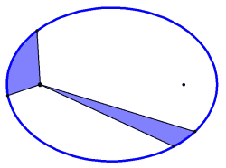
    - As a result of conservation of angular momentum
 $T^{2}≈a^{3}$

   - T is the orbital period
    - a is the length of the orbit’s semimajor axis

Oscillation

* Frequency (f): 1/period: number of occurrences in a cycle, in Hertz
* Period (T): 1/frequency: duration of a cycle, in seconds
* Oscillation about a stable equilibrium center
* Acceleration is proportional to the distance from the center
* Acceleration points in the direction to the center
* A cycle is when the oscillator returns to its starting position
 $T=\frac{2π}{ω}=\frac{1}{f}$

 $ω$ + is angular frequency
* 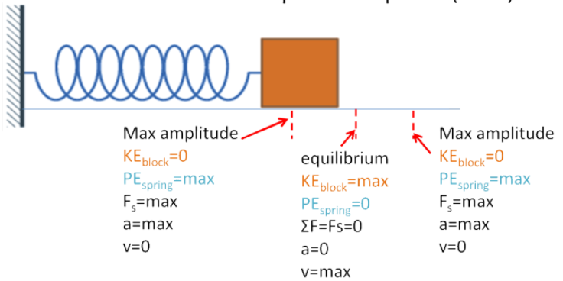
* 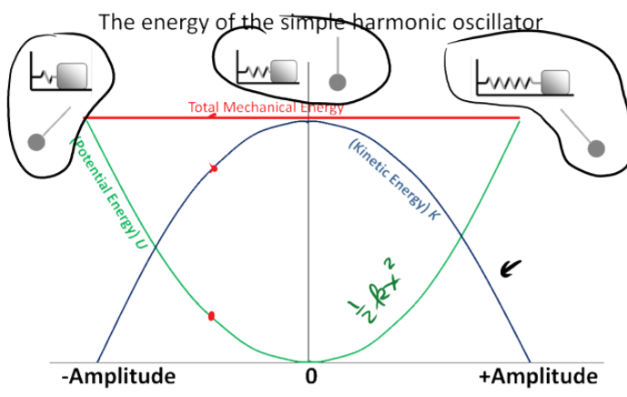
* Period for a mass on spring system: $T_{s}=2π\sqrt{\frac{m}{k}}$
* The position of the oscillator as a function of time: $x_{max}cos(ωt+ϕ)$
* To find $ω$, set up a Newton’s second law equation as a second order differential equation. Then, manipulate to $\frac{d^{2}x}{dt^{2}}=-ω^{2}x$ form